Redirecting Request from one Servlet to another:

There are three types of redirection

- Forward
- Include
- Send redirect

Forward method
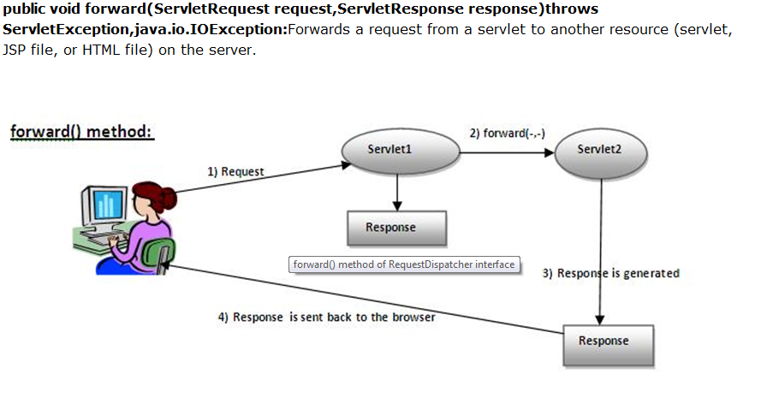

Sample Code:
RequestDispatcher dis=request.getRequestDisaptcher(“servlet2”);
dis.forward(request,response);

Include Method
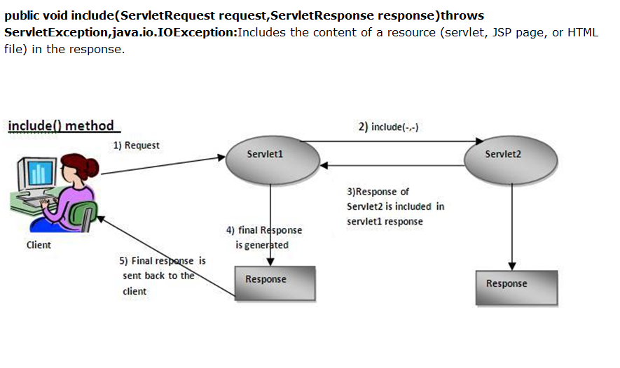
Sample Code:
RequestDispatcher dis=request.getRequestDisaptcher(“servlet2”);
dis.include(request,response);
Send Redirect Method

resp.sendRedirect("http://www.yahoo.co.in");
Servlet A
SendRedirect()

Request comes to Servlet A
Sent the another url address response to the user

Data management in Web Applications
Data in Web
Parameter Data – Web Application receive the data from user request and web.xml.
Attribute Data – Creating objects in the application.
There are three scopes of data.
Request – Store the data in the request used for processing the request.
Session - Store user data in the session and to be accessed only by that user.
Application – Store in the Application it can be accessed by all the servlet and request.

ServletConfig Object
An object of ServletConfig is created by the web container for each servlet. This object can be used to get configuration information from web.xml file.
If the configuration information is modified from the web.xml file, we don't need to change the servlet. So it is easier to manage the web application if any specific content is modified from time to time.

Methods of ServletConfig interface
- public String getInitParameter(String name):Returns the parameter value for the specified parameter name.
- public Enumeration getInitParameterNames():Returns an enumeration of all the initialization parameter names.
- public String getServletName():Returns the name of the servlet.
- public ServletContext getServletContext():Returns an object of ServletContext.
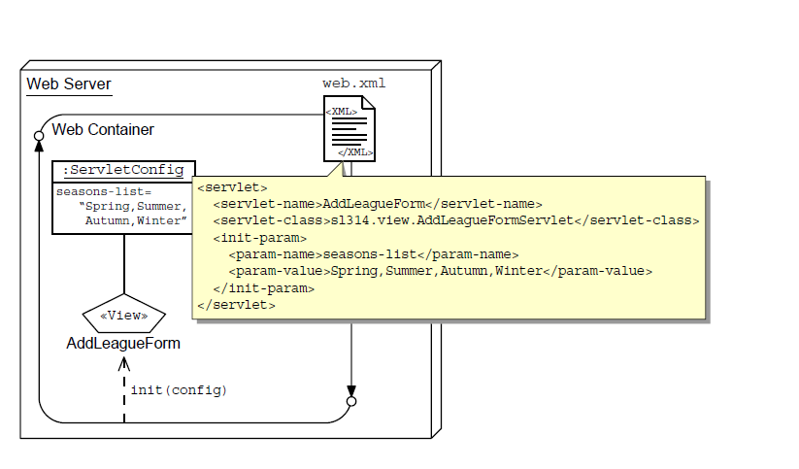

Sample Demo for ServletConfig
<web-app>
<servlet>
<servlet-name>DropDownServlet</servlet-name>
<servlet-class>com.test.DropDownServlet</servlet-class>
<init-param>
<param-name>role</param-name>
<param-value>Admin,Manager,Employee,Staff</param-value>
</init-param>
</servlet>
<servlet-mapping>
<servlet-name>DropDownServlet</servlet-name>
<url-pattern>/DropDownServlet</url-pattern>
</servlet-mapping>
</web-app>

package com.test;
import java.io.IOException;
import java.io.PrintWriter;
import javax.servlet.ServletConfig;
import javax.servlet.ServletException;
import javax.servlet.http.HttpServlet;
import javax.servlet.http.HttpServletRequest;
import javax.servlet.http.HttpServletResponse;

public class DropDownServlet extends HttpServlet {
protected void doGet(HttpServletRequest request, HttpServletResponse response) throws ServletException, IOException {
PrintWriter out=response.getWriter();
response.setContentType("text/html");
out.print("<html>");
out.print("<head>");
out.print("<title>My Page</title>");
out.print("</head>");
out.print("<body>");
out.print("<h1>Servlet Config Demo</h1>");
out.print("<form>");
ServletConfig config=getServletConfig();
String roles=config.getInitParameter("role");
String[] role=roles.split(",");
out.print("<select name=\"role\">");
out.print("<option value=\"uk\">Select...</option>");
for(String s:role){
out.print("<option value='"+s+"'>"+s+"</option>");
}
out.print("</select>");
out.print("</form>");
out.print("</html>");
}
}

ServletContext Object
An object of ServletContext is created by the web container at time of deploying the project. This object can be used to get configuration information from web.xml file. There is only one ServletContext object per web application.
If any information is shared to many servlet, it is better to provide it from the web.xml file using the <context-param> element.
Advantage of ServletContext
Easy to maintain if any information is shared to all the servlet, it is better to make it available for all the servlet. We provide this information from the web.xml file, so if the information is changed, we don't need to modify the servlet. Thus it removes maintenance problem.
Usage of ServletContext Interface
There can be a lot of usage of ServletContext object. Some of them are as follows:
- The object of ServletContext provides an interface between the container and servlet.
- The ServletContext object can be used to get configuration information from the web.xml file.
- The ServletContext object can be used to set, get or remove attribute from the web.xml file.
- The ServletContext object can be used to provide inter-application communication.
Commonly used methods of ServletContext interface
There is given some commonly used methods of ServletContext interface.
- public String getInitParameter(String name):Returns the parameter value for the specified parameter name.
- public Enumeration getInitParameterNames():Returns the names of the context's initialization parameters.
- public void setAttribute(String name,Object object):sets the given object in the application scope.
- public Object getAttribute(String name):Returns the attribute for the specified name.
- public Enumeration getInitParameterNames():Returns the names of the context's initialization parameters as an Enumeration of String objects.
- public void removeAttribute(String name):Removes the attribute with the given name from the servlet context.

home.html

<!DOCTYPE html PUBLIC "-//W3C//DTD HTML 4.01 Transitional//EN" "http://www.w3.org/TR/html4/loose.dtd">
<html>
<head>
<meta http-equiv="Content-Type" content="text/html; charset=ISO-8859-1">
<title>Welcome page</title>
</head>
<body>
Welcome Page of the Web Application
<a href="A">Servlet A</a>
<a href="B">Servlet B</a>
</body>
</html>

A.java Servlet
package com.test;

import java.io.IOException;
import java.io.PrintWriter;

import javax.servlet.ServletConfig;
import javax.servlet.ServletContext;
import javax.servlet.ServletException;
import javax.servlet.http.HttpServlet;
import javax.servlet.http.HttpServletRequest;
import javax.servlet.http.HttpServletResponse;
public class A extends HttpServlet {

protected void doGet(HttpServletRequest request, HttpServletResponse response) throws ServletException, IOException {
PrintWriter out=response.getWriter();
response.setContentType("text/html");
out.print("<html>");
out.print("<head>");
out.print("<title>My Page</title>");
out.print("</head>");
out.print("<body>");
out.print("<h1>Servlet Context Demo</h1>");
ServletContext context=getServletContext();
String value=context.getInitParameter("copyright");
out.println("This is Servlet A");
out.println("Copy Right Information From"+value);
out.print("</form>");
out.print("</html>");
}

}

B.java Servlet
package com.test;

import java.io.IOException;
import java.io.PrintWriter;

import javax.servlet.ServletConfig;
import javax.servlet.ServletContext;
import javax.servlet.ServletException;
import javax.servlet.http.HttpServlet;
import javax.servlet.http.HttpServletRequest;
import javax.servlet.http.HttpServletResponse;

public class B extends HttpServlet {
protected void doGet(HttpServletRequest request, HttpServletResponse response) throws ServletException, IOException {
PrintWriter out=response.getWriter();
response.setContentType("text/html");
out.print("<html>");
out.print("<head>");
out.print("<title>My Page</title>");
out.print("</head>");
out.print("<body>");
out.print("<h1>Servlet Context Demo</h1>");
ServletContext context=getServletContext();
String value=context.getInitParameter("copyright");
out.println("This is Servlet B");
out.println("Copy Right Information From"+value);
out.print("</form>");
out.print("</html>");
}

}

